

**Discipline**

**Problem Statement**

**CS5201**

Stage-1

**Sheikh Muhammed Tadeeb (AU19B1014)**

* **Domain Selection:**

|  |
| --- |
| **Domain** |
| Business |

* **Title:**

Digital empowerment of business

* **Problem Statement:**

Maintaining records of goods in factories or shops is a cumbersome procedure as it makes it difficult to build profitable business strategies and makes tracking of goods & credit on customers a hectic task.

* **Objective:**

1. To collect the various parameters of goods purchased from the wholesaler.
2. To collect the various parameters of goods sold to different retailers.
3. Analyzing the goods data and making profitable business decisions.
4. Keeping a track of credit amount on business.
5. Keeping a track of credit amount on customers.
6. Developing business customers bonds.

* **Objective Brief:**

The main aim of this project is to propose a desktop application that helps the businessmen to maintain their records digitally. The biggest hurdle that all businessmen face today is the management of hardcopies which hold all their records. This system allows businessman to access their data fast and easily. Secondly keeping a check on how much amount is due on them and how much amount is due on their customers becomes very easy with desktop application without wasting time in searching hard-coded records. For better understanding refer the image given below

(Fig 1).

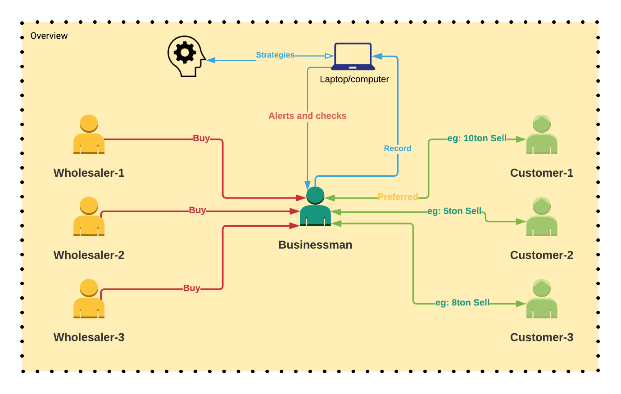

Fig 1

* **Origin of the research work:**

Well, my uncle is having a business of metallic sheets which he buys on credit basis from different wholesalers. The frequency of this deals is weekly. When he sells it to his customer, he either sell it in cash or on credit. When selling goods on credit he puts some condition on the customer i.e. the customer needs to pay a fixed amount (decided by seller) every week. Secondly, he had to keep track of profits gained on particular type of sheets at particular duration of the year. This whole procedure is recorded in hardcopies which makes it very time consuming and hectic. So, I decided to make a desktop application which can make this procedure automatic and time saving.

* **Why this problem matters/ need of this project:**

The following are the points why I decide to choose this as my course project statement:

1. These days businessmen are focusing more on saving time. So, they are gradually switching to digital platforms with good security aspects where they can keep track of their business details like credit amount left on them as well as on different customers to whom they have sold their product.
2. Also making decisions based on the amount and type of goods sold in particular period of the year which could help them to increase their profits.

* **Scope of the project:**

In this era of digital world, business is one of the fields that has received a lot of attention from problem solvers. It is said that time is money. So, I also decided to make some contribution. The following are the points which tells the scope of project:

1. I propose a system that uses desktop application which keeps record of all the business records and helps the businessmen to make good decisions for their business.
2. My system requires the user to enter various goods/products detail (if required) in a desktop app.
3. The data goes in the database where the processing is done and profitable suggestions could be made based on the stored data.